A CATHOLIC WEDDING  Catholics desiring to be married at St. John the Baptist Parish should be attending Church every weekend and should have received the sacrament of reconciliation during the past year. At least one of the parties must be a registered member of the parish.  THE CEREMONY  There are a number of options which may be chosen for a Catholic wedding ceremony. These should be discussed with the priest/deacon who will celebrate the wedding. Readings must be selected from among those approved by the Catholic Church. Other readings may  not be used.  Normally, the marriage of two Catholics will take place during the Mass. When either the bride or the groom is not Catholic, the Mass is not celebrated.  BOOKLET FOR READINGS  When you meet with the priest/deacon, he will give you a book entitled "Together for Life". The readings for your ceremony can be selected from this book.  PLACE FOR MARRIAGE  It is a diocesan law that a marriage ceremony can be held only in a church. No marriage ceremony can be permitted outdoors. |  | MARRIAGE PREPARATION  Preparation for marriage progresses through several stages.  First, the couple must meet with the priest/deacon who will celebrate the wedding.  * NO WEDDING DATE CAN BE SET  UNTIL THIS MEETING TAKES PLACE *  After the initial meeting, one of the couples on the marriage team will contact the couple to schedule a series of meeting at their home. The parish uses "Fully Engaged" as a resource to prepare couples for marriage.  Once these sessions are completed, the couple should contact the priest/deacon for the final session in which the details of the ceremony should be determined.  DOCUMENTS  The following documents must be presented to the priest/deacon:  - A certificate of baptism, obtained from the church of baptism and issued within six months prior to the date of the wedding.  - A civil marriage license, which should be presented the night of the rehearsal.  DECORATIONS  Flowers for the wedding are selected and purchased by the couple. It is customary to leave the flowers at the altar after the ceremony.  If pew flowers or ribbons are used, they must be fastened by masking tape or ribbons. No nails, tacks, clips, scotch tape, or other adhesives may be used.  An aisle cloth or runner is NOT permitted. |  | MASS / CEREMONY TIMES  Weddings may be scheduled on Saturdays beginning at 11:00 a.m. The wedding Mass may begin no later than 1:30 p.m. If there is a wedding ceremony ONLY, this may begin no later than 2:00 p.m. This allows the parking lot to be cleared for afternoon confessions and Mass.  WEDDING MUSIC PREPARATION  Please contact the music director of the parish as soon as your date is scheduled. Please call the Parish office at 740-392-4711.  Liturgical wedding music services will include:  - Conference and planning time with the bride and groom, the celebrant, and the cantor/soloist  - Rehearsal and practice time with the cantor/soloist and organist  - Rehearsal time with the wedding party during the rehearsal  - Music at the wedding mass/ceremony  The cost for wedding music is $450.00. Please make a check payable to:  St. John the Baptist Parish  303 E High. St.  Mt. Vernon, OH 43050  and mail it fifteen days prior to the wedding.  OFFERING  The customary offering to the priest/deacon is $250.00. A donation of $200.00 to the church is also suggested.  SERVERS  The customary offering for the two servers for Mass is $20.00 each. No servers are needed when there is not a Mass.
REHEARSAL  The wedding party should be ON TIME for the 45-minute practice. In addition to the wedding party, readers and anyone else who will perform a specific function (gift bearers, extraordinary minister of Holy Communion, e.g.) must be present.  DRESSING  The bridal party may use the grade school or the belfry to dress. This room must be left after the wedding in the same condition in which it was found. Please make known at the rehearsal what time the school or church needs to be unlocked.  FLORIST  The florist arranges the flowers and furnishes the candelabra. If a candelabra is used, we require that the florist provides dripless candles or hurricane globes.  PHOTOS  The photographer is expected to see the priest/deacon before the wedding concerning recording equipment. Flash pictures are not to be taken once the ceremony or Mass begins.  NOT PERMITTED  - The receiving line is appropriately held at the reception. There is NO receiving line at the church after the wedding.  - The throwing of rice, birdseed, or confetti is strictly forbidden  - Alcoholic beverages are strictly forbidden on the premises.  - The ‘Unity Candle’ is not part of the Catholic Marriage rite and is not permitted. |  | 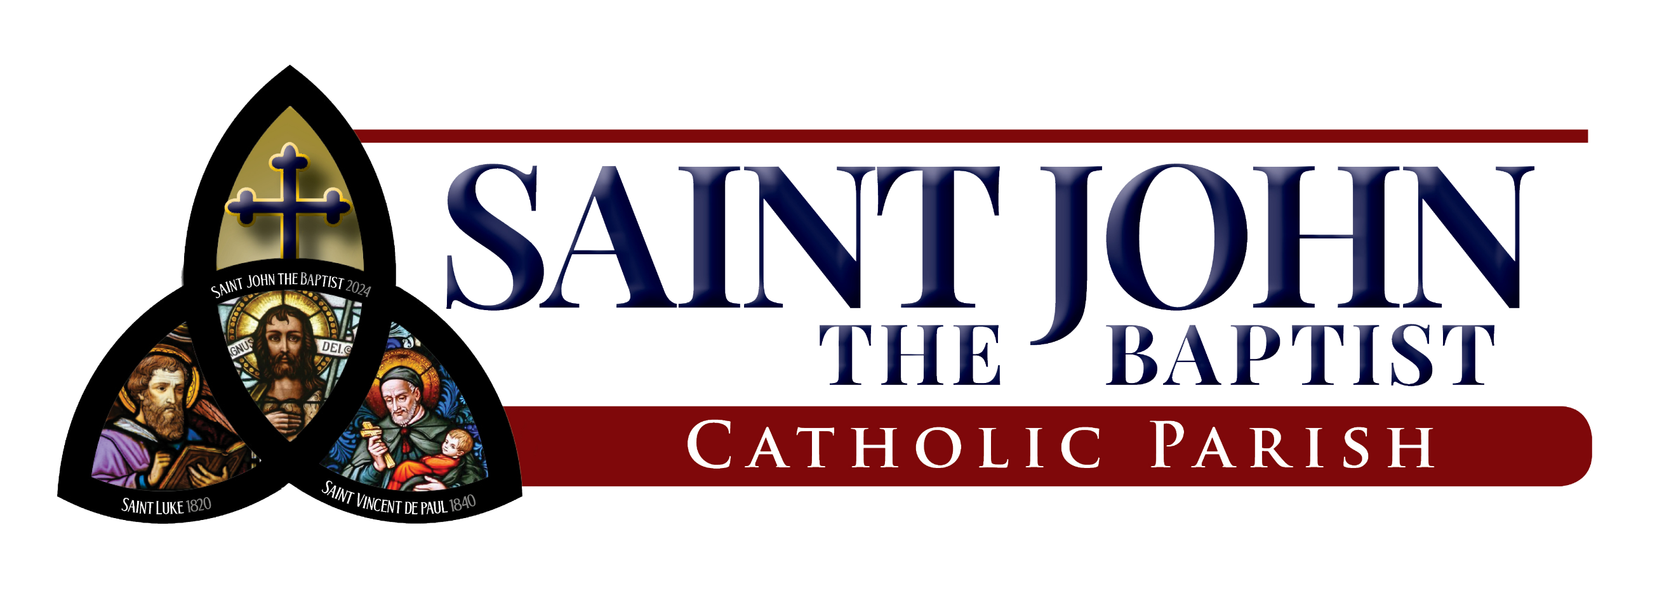  St. John the Baptist Parish  St. Vincent de Paul Church  St. Luke Church  303 E High Street, Mount Vernon, OH 43050  www.knoxcatholic.org  Office: 740-392-4711  svdp@knoxcatholic.org | 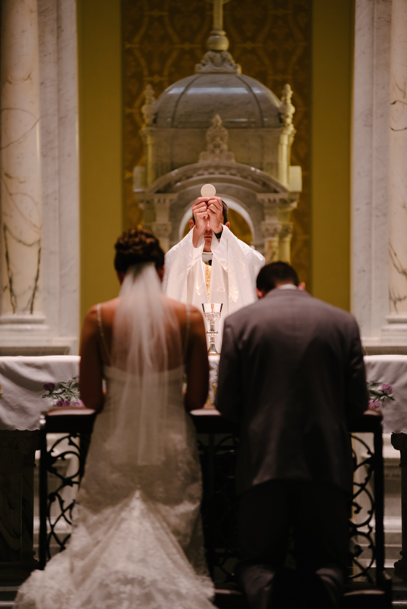 | PLANNING YOUR MARRIAGE  

